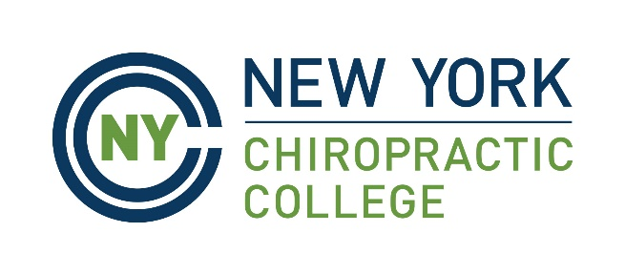

FOR IMMEDIATE RELEASE: April, 2021

[City Name] Resident Earns Doctorate from New York Chiropractic College
SENECA FALLS, NY — [Graduate’s full name] of [City, State, Country] graduated with their Doctor of Chiropractic degree from New York Chiropractic College at the College’s recent April 3, 2021, online commencement ceremony.
While at NYCC, [last name] completed a rigorous three-year academic curriculum, including an extensive hands-on clinical rotation at [clinical placement location]. [Last name] also [any other relevant activity, earned honors or academic focus you’d like to include].
Dr. [Last name] plans to work at [insert name of practice or organization, or outline general plans] after graduation.
New York Chiropractic College in Seneca Falls, NY, is recognized as a leading institution for the education and training of natural healthcare professionals and academicians, and its graduate programs in areas such as chiropractic and health sciences and education are rooted in a commitment to academic excellence, leadership, and professional best practices. For more information, visit www.nycc.edu.

### END ###

